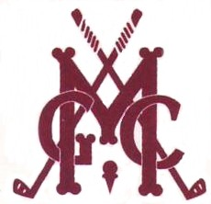
The MORWELL GOLF CLUB
Ladies invite you to
join us at the

Cath Little Day.

Friday 12 ^{th} March 2021
Sponsored by ‘TOP PUB’

Event: 4BBB Stableford

Start: 9:00 assemble for 9:30 Shotgun Start

Trophies: Winners, Runners-up & DTL - NTPs

Entry fee: $24.00 per pair

Entries Close: 6th March, 2021

Lunch: To be paid for on arrival (Please advise of any dietary requirements)

Entry form:
Name | G.A.Hcap | Partner | G.A.Hcap
Golflink No. |  | Golflink No.
Golflink No. |  | Golflink No.
Golflink No. |  | Golflink No.
Golflink No. |  | Golflink No.

Club: _____________________________ Total Entry fee payable: $ ______________

Contact: ___________________________ Phone No:____________________

All payments must be Direct Debit – Please put name on reference.
There will be no refunds once payment is made.
Return entries to Ladies Secretary via email: nikkitepaa@gmail.com or

Payment to be made via Direct Debit to BSB: 633-000 Account No: 112978333
***** NOTE: Ladies Secretary must be notified when payment is made *****

